French Vanilla Flavoured Instant Panna Cotta Powder  Record ID: 6108099  Company: Karniel Pacific Indonesia  Manufacturer: Karniel Pacific Indonesia  Distributor: Ksatria Pacific  Brand: Dessert Factory  Category: Desserts & Ice Cream  Sub-Category: Shelf-Stable Desserts  Market: Indonesia  Store Name: Hokky Family  Store Type: Supermarket  Store Address: Surabaya 60226  Date Published: Nov 2018  Product source: Shopper  Launch Type: New Product  Price in local currency: IDR16500.00  Price in US Dollars: 1.08  Price in Euros: 0.95  Bar Code: 8997204780611 | 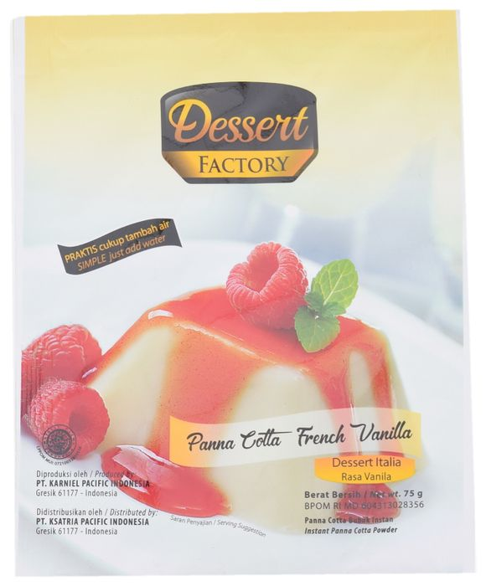
Product Description
Dessert Factory Panna Cotta Bubuk Instan Rasa Vanila (French Vanilla Flavoured Instant Panna Cotta Powder) is described as an instant panna cotta ready mix with a luxurious taste, and said to be easy and quick to prepare by simply adding water. The halal certified product retails in a 75g pack, featuring the Facebook, Twitter and Instagram logos.
Packaging Details
 | Primary
Package Type | Flexible sachet
Package Material | Multi laminate

Product Analysis
Pack Size: 75.000 g
Storage: Shelf stable
Formats & Textures (Beauty & Personal Care):
Textures (Food & Drink):
Alcohol By Volume (%):
Private Label: Branded
Store Type: Supermarket
Product Variants
Product Variant | Flavours | Format Type | Claims | Still Selling
French Vanilla Flavoured Instant Panna Cotta Powder | Vanilla (French) & Panna Cotta/Pannacotta | — | Halal,  Time/Speed,  Ease of Use,  Social Media | —

Matcha Flavoured Instant Panna Cotta Powder | Matcha/Maccha (Green Tea) & Panna Cotta/Pannacotta | — | Halal,  Time/Speed,  Ease of Use,  Social Media | —
Double Chocolate Flavored Instant Panna Cotta Powder | Panna Cotta/Pannacotta | — | Halal,  Time/Speed,  Ease of Use,  Social Media | —

Ingredients (Standard form): Milk Powder (Powdered), Whipping Cream (Cream, Powdered), Non Dairy Creamer (Vegetable Based, Creamer), White Sugar, Beef Gelatine (Gelling Agents, Gelling Agent), Vanilla Extract (Extract)
Ingredients (On Pack): milk powder, whipping cream powder, vegetable creamer, sugar, gelling agent beef gelatin, vanilla extract (0.254%)
Nutrition: Per 75g serving (1 serving per pack): Energy 340kcal, Total fat 13g (19% RDA), Protein 11g (18% RDA), Total carbohydrates 46g (14% RDA) (of which Sugars 24g), Sodium 270mg (18% RDA)
Branded Comparison:
Annotations

Additional Product Images
